WEEK 3 – MONGODB CONNECTIVITY

Step-01: Download MongoDB Compass
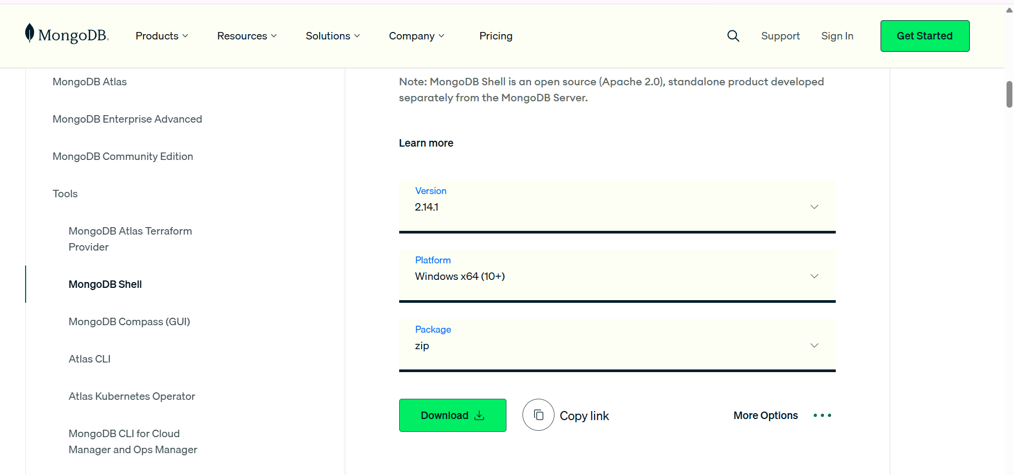
Step-02: Install MongoDB Community Server
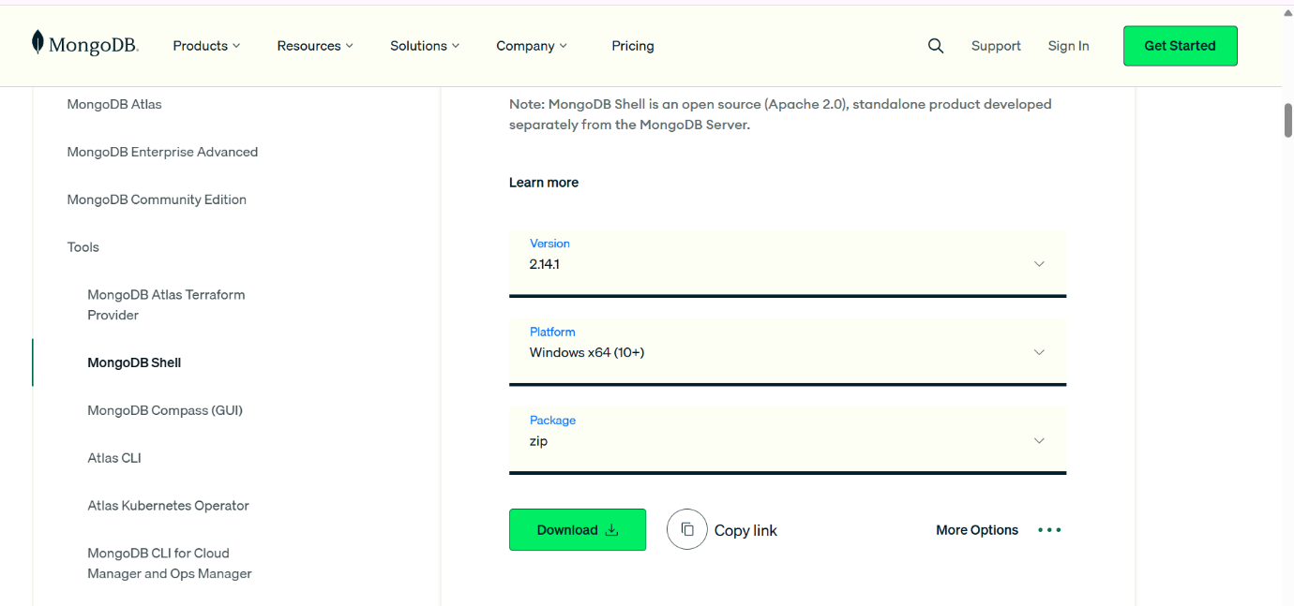

Step-03: Create MongoDB Database and Collection
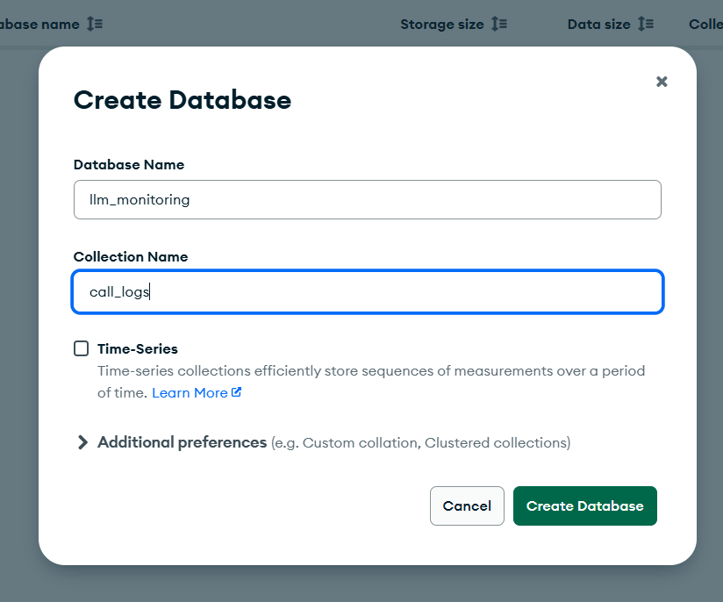

Step-05: Download Llama 3.2 Model
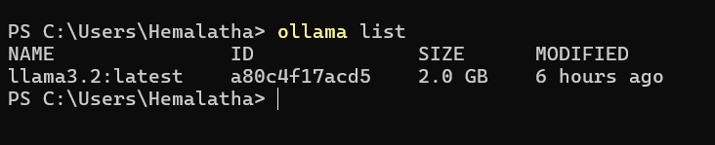
Step-06: Create Week-3 Project Files
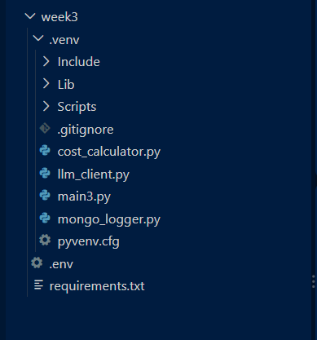
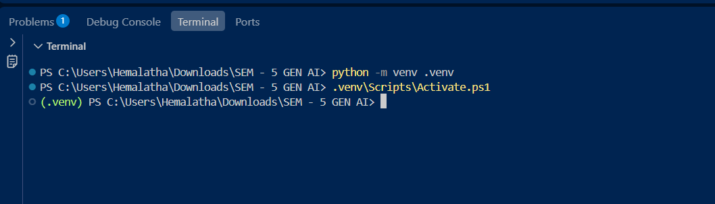
Step-07: Implement Cost Calculator
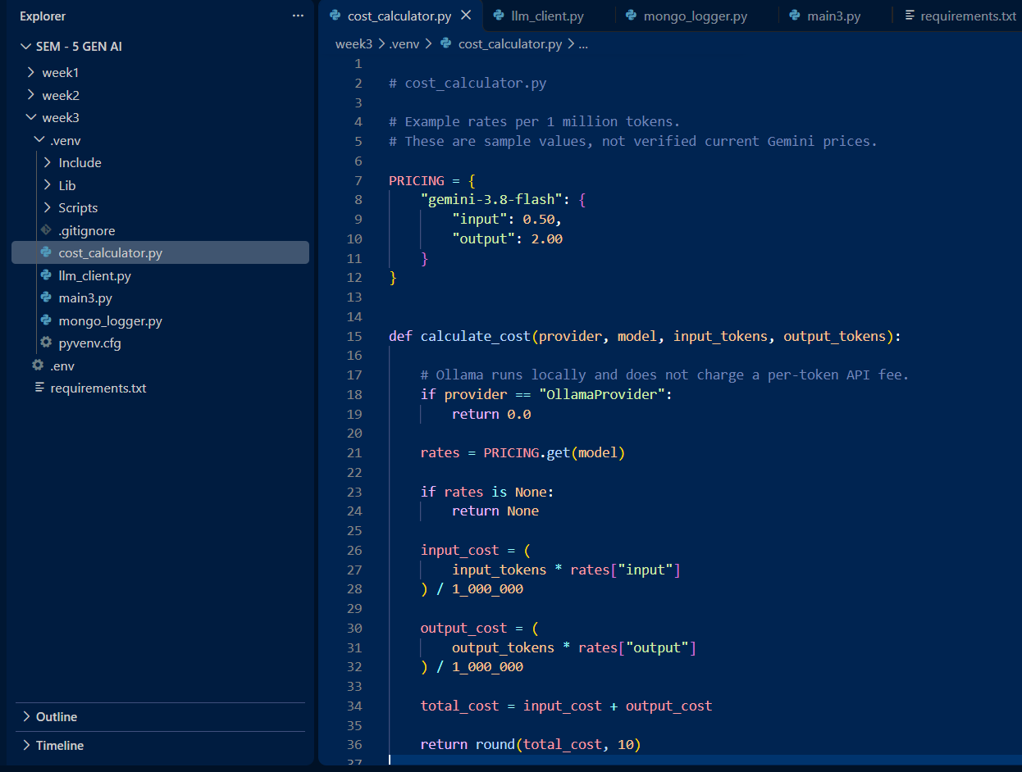
Step-08: Implement LLM Client
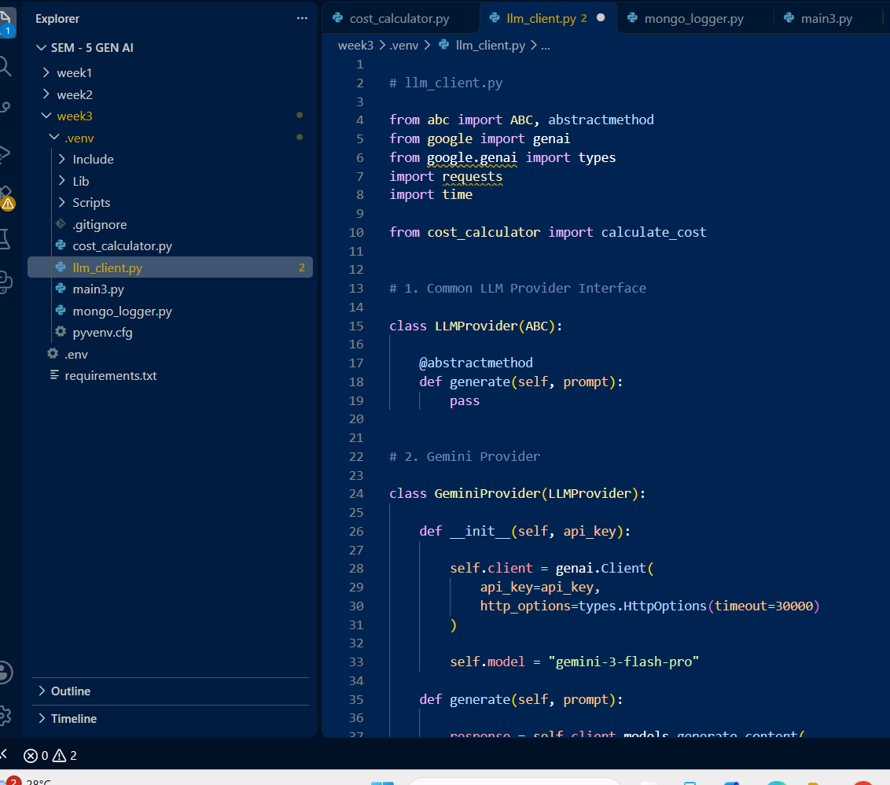
Step-09: Implement MongoDB Logger
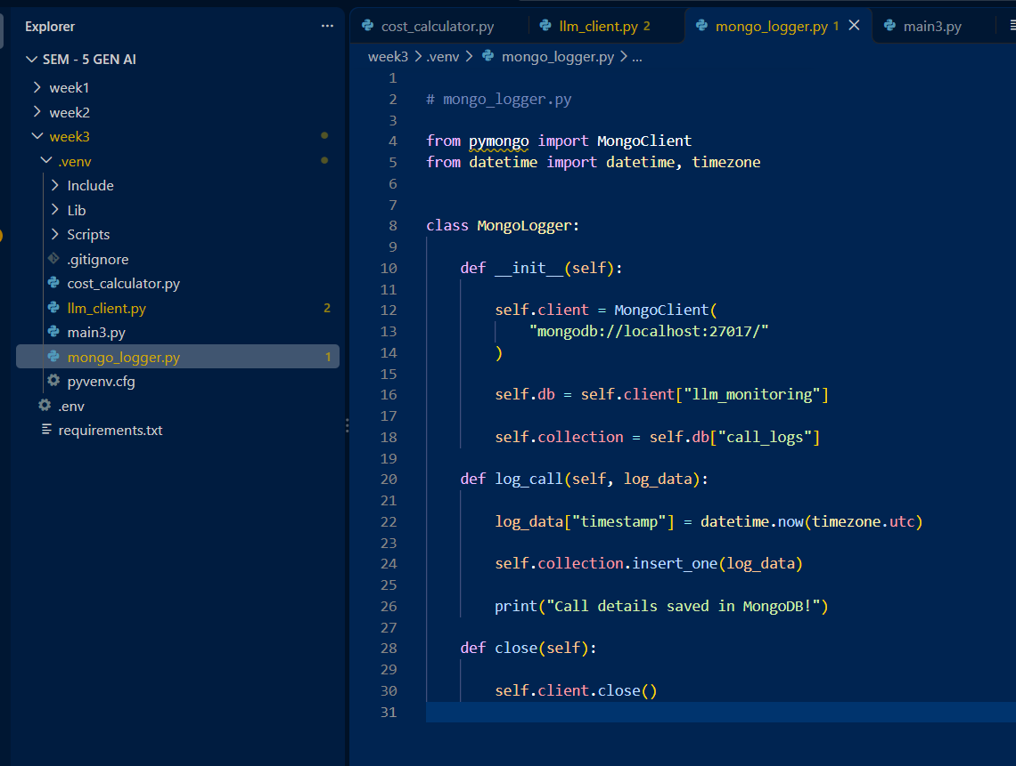
Step-10: Configure Environment Variables
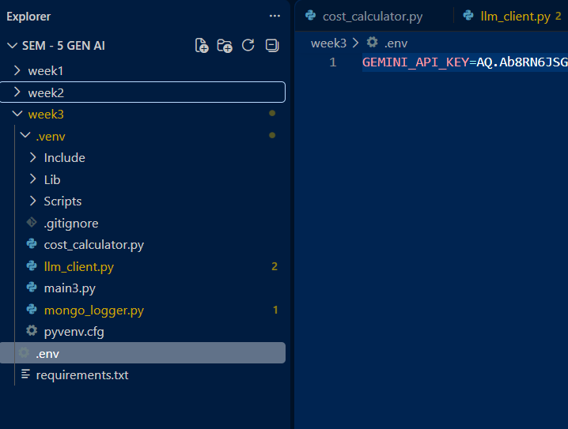
Step-11: Implement Main Program
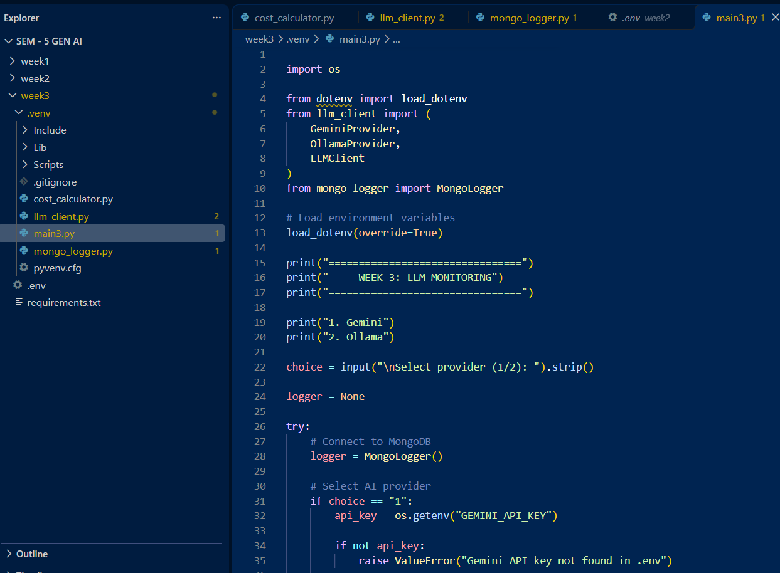
Step-12: Install Dependencies
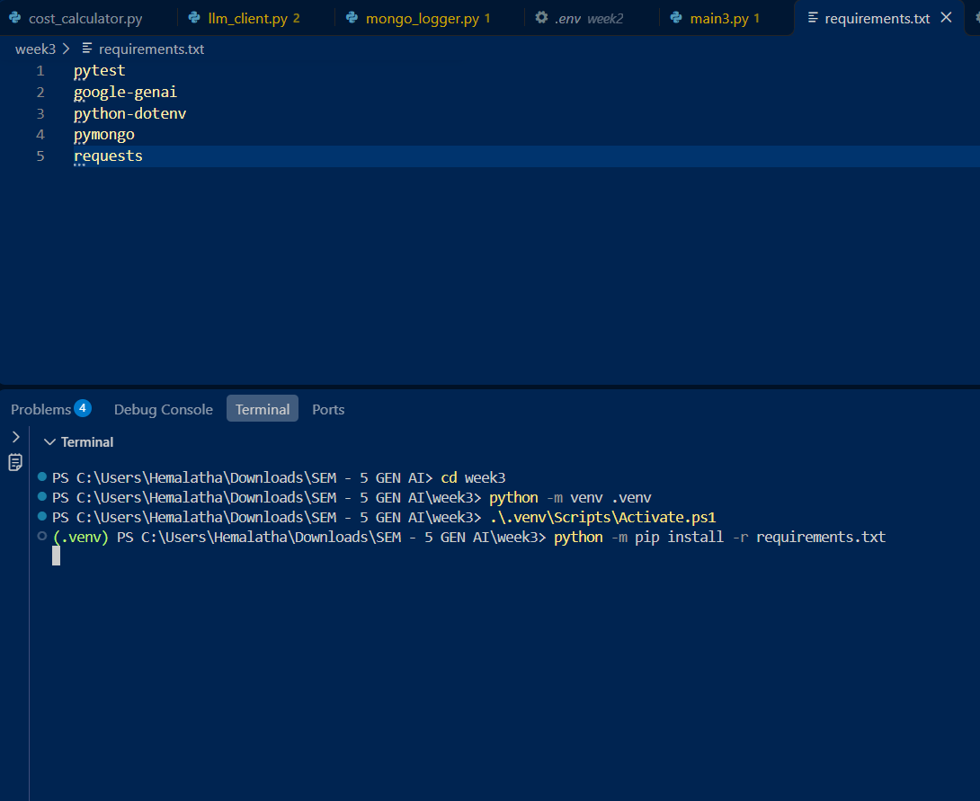
Step-13: Execute and Test Application
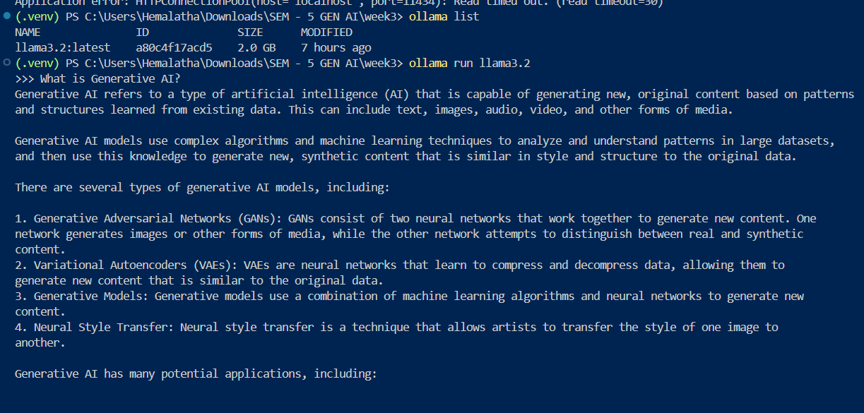
Step-14: Verify MongoDB Logs
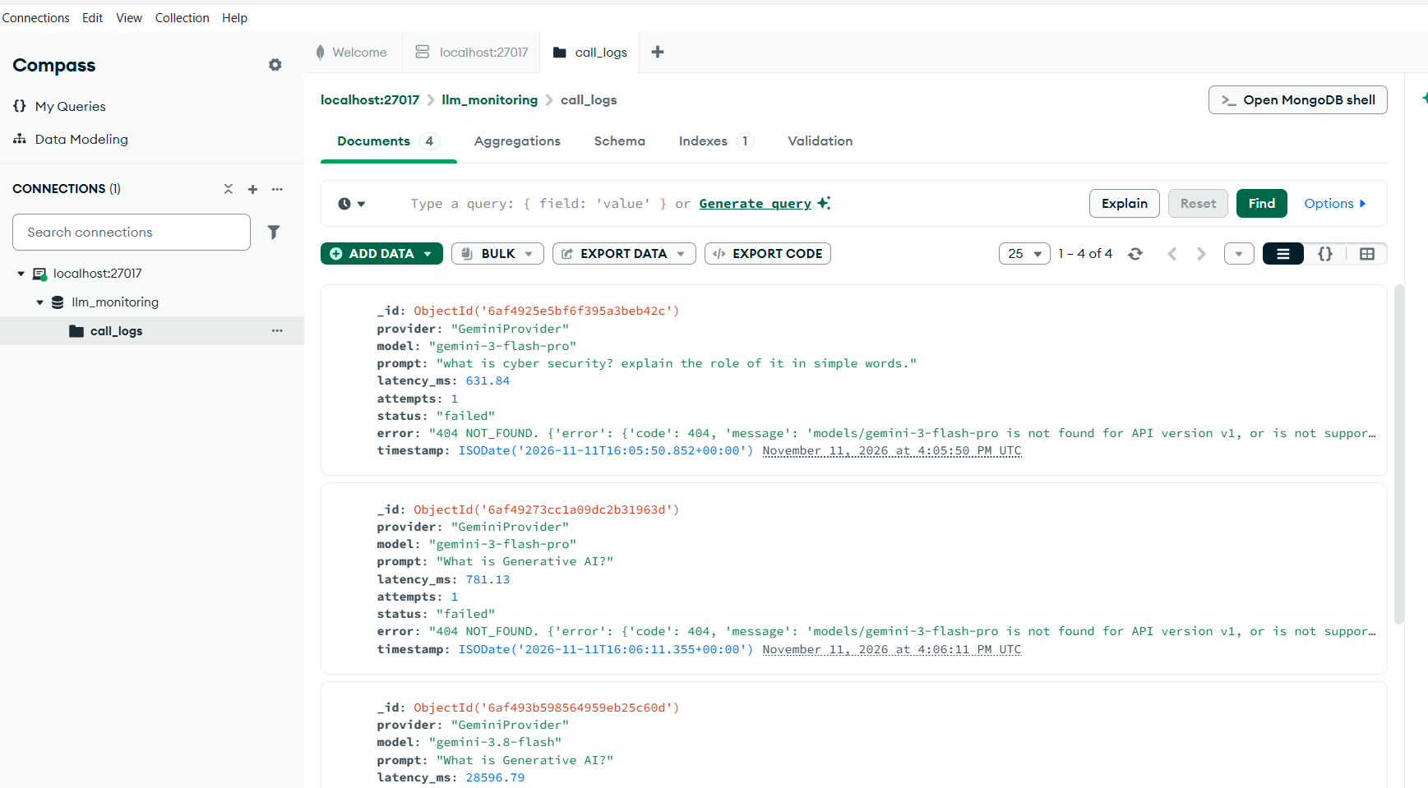
Step-15: Push Week 3 to GitHub

